When experiencing an error not thrown by the API itself, there are a couple placed to check.

Especially if the API works but doesn’t respond properly during some specific calls or when called multiple times in succession:

First: check cloudwatch:

* Was the Lambda function run?
  + If so, this means API gateway is properly called the Lambda function. However, the configurations of the lambda function likely needs tweaking. In this case, Cloudwatch will give you the most clues about what has happened.
  + This will likely include going to the configurations section:
  + 
  + And looking at the settings within:
  + 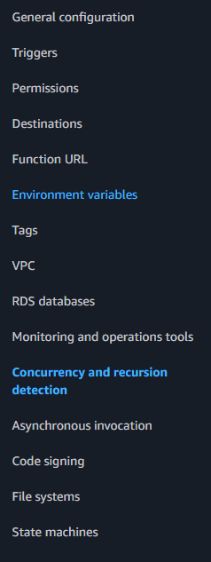
  + Concurrency and recursion detection, or asynchronous invocation.
  + Additionally, check the resources given to the lambda functions and ensure they are sufficient (timeout time, memory)
* If the cloudwatch shows the lambda was never run in the first place, the problem likely lies in the api gateway
  + Gateway response can have information about what went wrong
  + 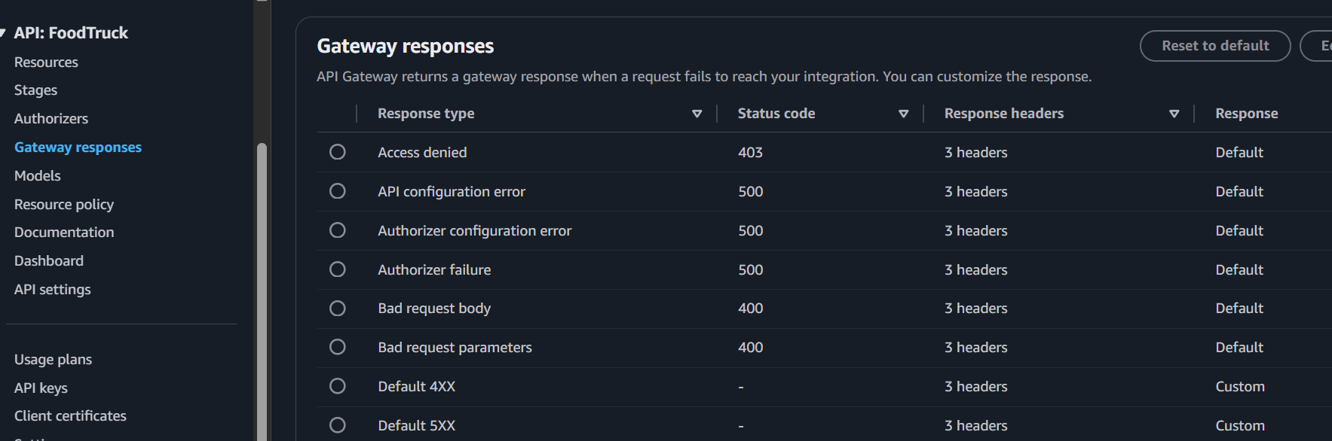
  + One of the other places to take a look at is the stages section of the API
  + 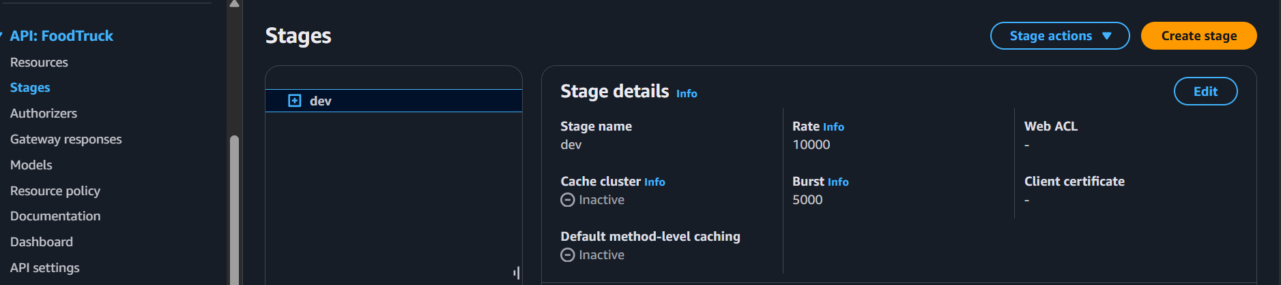
  + Especially the rate or burst section. If they are insufficient, too many concurrent API calls may prevent responses as the API gateway is overloaded with requests.